 |  | Mathematics Essentials 2017  Test 3 Unit 2  Task Weighting: 7%
Student Name:

Time Allowed: 25 Minutes Total Marks: 27

PART A Calculators are NOT allowed in this section.

Question 1 (4 Marks: 2, 1, 1)

- Convert the following times to those in brackets:
i) 1045 h (12 hr) _________ ii) 12:35 am (24 hr) ________ iii) 2331 h (12 hr) __________

- Calculate the elapsed time from 2:45 pm until 8:20 am the following day.

- What is the time 2 hrs before midday?

Question 2 (3 Marks: 1, 2)

- Vanessa’s flight lands in Singapore at 0840h. Her next flight leaves Singapore at 1820h. How long does Vanessa have in the Singapore airport?

- Peter wants to go for a bike ride which takes 52 minutes. He also wants to watch his favourite television show which starts at 7:35 p.m. What is the latest time that he can leave for his bike ride and be back in time to watch television?

Question 3 (2 marks)
Tom and Jerry competed against each other in a race. Tom completed the race in in 0.75 hours while Jerry took 50 minutes.
Who won the race? Explain your answer

Question 4 (5 marks: 1, 2, 2)

At Eastern Goldfields College, Period 1 starts at 8:20 am every morning.

- If Mark wakes up an hour and a half before school starts, what time does he wake up?

- How much time has elapsed from the start of Period 1 to Lunch 2 at 12:45 pm?

- If school finishes at 3:15 pm and Samantha starts work 1 hour and 55 minutes later, what time does she begin work?

Question 5 (5 marks: 1, 1, 1, 2)

- Convert this graphical scale into a fractional scale (i. e. 1: __________)

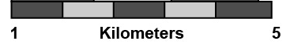
5
0

- 1 cm to 200 m can be written as 1: ___________

- A map scale of 1 : 3000 means 1 cm on the map represents ___________ metres in real life

- If the length of a room was 560cm and the floor plan scale was 1:80, how long
would the line be drawn on the plan?

Question 6 (8 Marks: 1, 1, 2, 2, 2)
The following graph shows the distance of a cyclist from his home

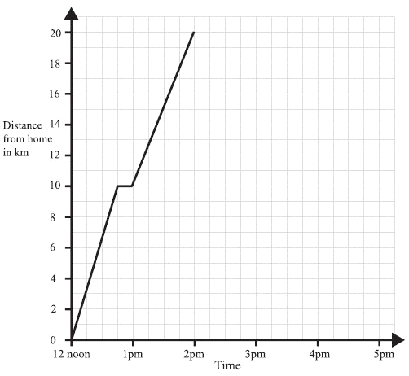
a) For how long did he rest initially (for the first time)?

b) How far away from home was he at 1.30 pm?

c) What may have happened when he was 10 km from home before 1 pm? Explain.

d) What was his ‘average’ speed for the entire bike ride?

- i) How can you tell from the graph when the cyclist was travelling most quickly?

ii) Between what times did this occur?

End of Part A
Mathematics Essentials 2017

Test 3 Unit 2

Task Weighting: 7%

Student Name: _________________________________________________

Time allowed: 25 minutes Total marks: 23

PART B Calculators and notes are allowed in this section.

Show all working where appropriate to maximise marks.

Question 7 (6 marks: 4,2)

Three different families drove their cars from one town to another as they enjoyed their holidays. They used a map of the south-west region of Western Australia which has a scale of 1:750 000. Pairs of towns are listed in the table together with some actual distances. The weather conditions required them to travel at different speeds.

FAMILY  NAME | SOUTH-WEST TOWNS | DISTANCE  (km) | MAP DISTANCE (cm) | AVERAGE SPEED( km/h) | TIME TO TRAVEL ( h)
Smith | Bunbury to Augusta | 142 | 19 | 95
Brown | Walpole to Busselton | 238 |  |  | 2
Jackson | Donnybrook to Bridgetown |  | 7.5 |  | 0.6

- Use your knowledge of distance, speed, time and scale to complete the table.

- One of the families broke a traffic rule. Which family broke the law? Explain your answer.

Question 8 (8 Marks: 2, 2, 2, 2)

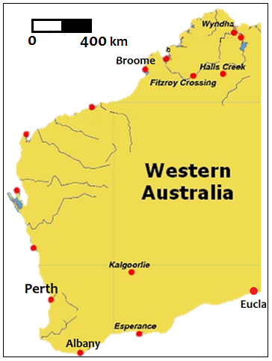
a) Write the graphical scale shown on the map, as a fractional scale.

b) The approximate shortest distance from Perth to Broome is 1680 km. Explain, using the scale and with calculations, how this result has been obtained.

c) Use the map to estimate the distance (as the crow flies) between Albany and Eucla.
Show how you have calculated your answer.

d) Could you use this distance to calculate the driving time between the two locations? Explain your answer.

Question 9 (4 marks)

What time should Chris set his alarm clock for? Use the information below to help you decide.

The leisure centre opens at 6 am Monday to Friday. Chris needs to arrive at work at 9 am.

Chris wakes up at 20 minutes before he leaves the house. It takes 0.25 hours to get from his house to the leisure centre. It takes him 35 minutes to get from the leisure centre to work.

He wants to spend a total of 1 hours at the leisure centre. Chris wants to wake up as late as possible. He needs to work out what time to set his alarm clock for.

Use the box below to show clearly how you get your answer.

Question 10 (5 marks)

Sheila works for Ace Taxis.

Ace Taxis uses three taxis: Alpha, Beta and Charlie

Sheila takes bookings from customers who want taxis.

Booking Sheet for Tuesday
Customer | From | To | Pick up Time | Drop off time | Journey time  (in minutes) | Taxi
School run | Grindley Street | Merton School | 8:15 | 9:00 | 45 | Alpha
School run | Marsh  Bank | Merton School | 8:15 | 9:00 | 45 | Charlie
Miss Egan | Boston Road | Station | 7:00 | 7:15 | 15 | Alpha
Ms Green | Bank Street | Clinic | 10:05 | 10:30 | 25 | Beta
Mrs Adams | Copley Estate | Shopping Centre | 9:25 |  | 20
Miss Crispi | Shopping Centre | Green Lane Estate | 10:10 |  | 25
Mr Smith | Copley Estate | Station | 7:20 |  | 25
Mr Micel | Rose Avenue | Shopping Centre | 9:40 |  | 25

Shelia makes a booking schedule to show which taxi will be sent to each customer.

She allows 15 minutes between dropping off one customer and picking up the next.

Shelia has written four bookings on the booking schedule.

Complete the booking sheet and the booking schedule to show which taxi will be sent to each customer.

Booking Schedule
Taxis | 7:00 | 8:00 | 9:00 | 10:00
Alpha | Miss Egan  (7:00 – 7:15) | School run  (8:15 – 9:00)
Beta |  |  |  | Ms Green  (10:05 – 10:30)
Charlie |  | School run  (8:15 – 9:00)

End of Part B

